1. **Create a new react application using *create-react-app* tool with the name as “blogapp”**

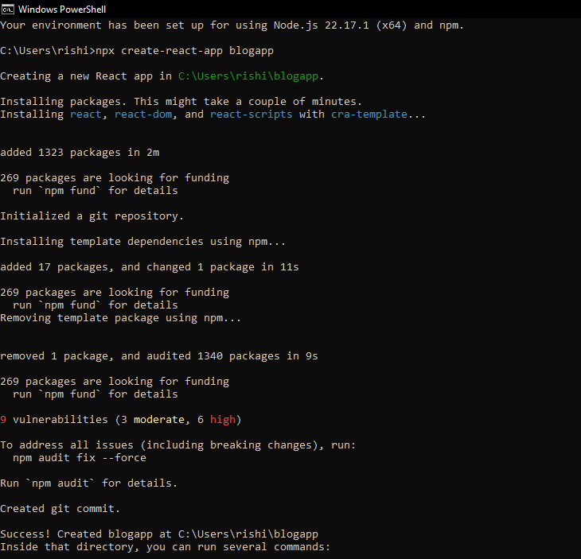 **Post.js**

// Post.js

class Post {

  constructor(userId, id, title, body) {

    this.userId = userId;

    this.id = id;

    this.title = title;

    this.body = body;

  }

}

export default Post;

**Posts.js**

  import React, { Component } from 'react';

import Post from './Post';

class Posts extends Component {

  constructor(props) {

    super(props);

    this.state = {

      posts: [],

      error: null

    };

  }

loadPosts = () => {

    fetch('https://jsonplaceholder.typicode.com/posts')

      .then(response => {

        if (!response.ok) {

          throw new Error('Failed to fetch posts');

        }

        return response.json();

      })

      .then(data => {

        const postObjects = data.map(p => new Post(p.userId, p.id, p.title, p.body));

        this.setState({ posts: postObjects });

      })

      .catch(error => {

        this.setState({ error });

      });

  };

  componentDidMount() {

    this.loadPosts();

  }

  componentDidCatch(error, info) {

    alert("An error occurred: " + error.message);

  }

  render() {

    const { posts, error } = this.state;

    if (error) {

      return <p>Error loading posts: {error.message}</p>;

    }

    return (

      <div>

        <h1>Posts</h1>

        {posts.map(post => (

          <div key={post.id} style={{ marginBottom: '20px' }}>

            <h3>{post.title}</h3>

            <p>{post.body}</p>

          </div>

        ))}

      </div>

    );

  }

}

export default Posts;

**App.js**

import React from 'react';

import Posts from './Posts';

function App() {

  return (

    <div className="App">

      <Posts />

    </div>

  );

}

export default App;

C:\Users\rishi\blogapp>npm start

